What is Spring JDBC?
Simple Definition (Fresher Level)
Spring JDBC is a module in Spring that makes database access easy by removing boilerplate JDBC code.

❌ Problem with Plain JDBC (Old Way)
In normal JDBC, you must write:
- Driver loading
- Connection
- Statement
- ResultSet
- Exception handling
- Resource closing
Example (plain JDBC ❌):
Connection con = DriverManager.getConnection(...);
PreparedStatement ps = con.prepareStatement("select * from emp");
ResultSet rs = ps.executeQuery();
while(rs.next()) {
System.out.println(rs.getString("name"));
}
rs.close();
ps.close();
con.close();
👉 Too much code, error-prone.

✅ Solution: Spring JDBC
Spring JDBC:
- Handles connection creation
- Handles closing resources
- Handles exceptions
- You write only SQL + mapping logic

🔥 Core Components of Spring JDBC
Component | Purpose
JdbcTemplate | Execute SQL easily
NamedParameterJdbcTemplate | Use named parameters
RowMapper | Convert DB rows → Java objects

✅ PROJECT: SpringJdbcDemo

📁 Project Structure
SpringJdbcDemo
└── src/main/java
└── com/example/demo
├── SpringJdbcDemoApplication.java
├── Employee.java
├── EmployeeRowMapper.java
├── EmployeeDao.java
└── EmployeeController.java
└── src/main/resources
└── application.properties
└── pom.xml

1️⃣ pom.xml (VERY IMPORTANT)
👉 Oracle JDBC + Spring JDBC + Web
<project xmlns="http://maven.apache.org/POM/4.0.0"
xmlns:xsi="http://www.w3.org/2001/XMLSchema-instance"
xsi:schemaLocation="http://maven.apache.org/POM/4.0.0
https://maven.apache.org/xsd/maven-4.0.0.xsd">

<modelVersion>4.0.0</modelVersion>

<groupId>com.example</groupId>
<artifactId>SpringJdbcDemo</artifactId>
<version>0.0.1-SNAPSHOT</version>
<packaging>jar</packaging>

<name>SpringJdbcDemo</name>

<properties>
<java.version>17</java.version>
</properties>

<parent>
<groupId>org.springframework.boot</groupId>
<artifactId>spring-boot-starter-parent</artifactId>
<version>4.0.2</version>
</parent>

<dependencies>

<!-- Spring Web -->
<dependency>
<groupId>org.springframework.boot</groupId>
<artifactId>spring-boot-starter-web</artifactId>
</dependency>

<!-- Spring JDBC -->
<dependency>
<groupId>org.springframework.boot</groupId>
<artifactId>spring-boot-starter-jdbc</artifactId>
</dependency>

<!-- Oracle JDBC Driver -->
<!-- If Maven fails, add ojdbc8.jar manually -->
<dependency>
<groupId>com.oracle.database.jdbc</groupId>
<artifactId>ojdbc8</artifactId>
<version>19.3.0.0</version>
</dependency>

<!-- DevTools (optional) -->
<dependency>
<groupId>org.springframework.boot</groupId>
<artifactId>spring-boot-devtools</artifactId>
<scope>runtime</scope>
</dependency>

</dependencies>

<build>
<plugins>
<plugin>
<groupId>org.springframework.boot</groupId>
<artifactId>spring-boot-maven-plugin</artifactId>
</plugin>
</plugins>
</build>

</project>

2️⃣ application.properties
spring.application.name=SpringJdbcDemo

spring.datasource.url=jdbc:oracle:thin:@localhost:1521:XE
spring.datasource.username=system
spring.datasource.password=admin
spring.datasource.driver-class-name=oracle.jdbc.OracleDriver

server.port=9999

3️⃣ Employee.java (MODEL / POJO)
package com.example.demo;

public class Employee {

private int id;
private String name;
private int salary;

public Employee() {}

public Employee(int id, String name, int salary) {
this.id = id;
this.name = name;
this.salary = salary;
}

public int getId() {
return id;
}

public void setId(int id) {
this.id = id;
}

public String getName() {
return name;
}

public void setName(String name) {
this.name = name;
}

public int getSalary() {
return salary;
}

public void setSalary(int salary) {
this.salary = salary;
}
}

4️⃣ EmployeeRowMapper.java
package com.example.demo;

import java.sql.ResultSet;
import java.sql.SQLException;
import org.springframework.jdbc.core.RowMapper;

public class EmployeeRowMapper implements RowMapper<Employee> {

@Override
public Employee mapRow(ResultSet rs, int rowNum) throws SQLException {

Employee emp = new Employee();
emp.setId(rs.getInt("id"));
emp.setName(rs.getString("name"));
emp.setSalary(rs.getInt("salary"));

return emp;
}
}

5️⃣ EmployeeDao.java (DAO Layer)
package com.example.demo;

import java.util.List;
import org.springframework.jdbc.core.JdbcTemplate;
import org.springframework.stereotype.Repository;

@Repository
public class EmployeeDao {

private final JdbcTemplate jdbcTemplate;

public EmployeeDao(JdbcTemplate jdbcTemplate) {
this.jdbcTemplate = jdbcTemplate;
}

public List<Employee> getAllEmployees() {
String sql = "SELECT * FROM employee";
return jdbcTemplate.query(sql, new EmployeeRowMapper());
}
}

6️⃣ EmployeeController.java (REST API)
package com.example.demo;

import java.util.List;
import org.springframework.web.bind.annotation.GetMapping;
import org.springframework.web.bind.annotation.RestController;

@RestController
public class EmployeeController {

private final EmployeeDao employeeDao;

public EmployeeController(EmployeeDao employeeDao) {
this.employeeDao = employeeDao;
}

@GetMapping("/employees")
public List<Employee> getEmployees() {
return employeeDao.getAllEmployees();
}
}

7️⃣ SpringJdbcDemoApplication.java
package com.example.demo;

import org.springframework.boot.SpringApplication;
import org.springframework.boot.autoconfigure.SpringBootApplication;

@SpringBootApplication
public class SpringJdbcDemoApplication {

public static void main(String[] args) {
SpringApplication.run(SpringJdbcDemoApplication.class, args);
}
}

8️⃣ ORACLE DATABASE SETUP (MANDATORY)
Run this in SQL Plus / SQL Developer 👇
CREATE TABLE employee (
id NUMBER PRIMARY KEY,
name VARCHAR2(50),
salary NUMBER
);

INSERT INTO employee VALUES (1, 'Ravi', 50000);
INSERT INTO employee VALUES (2, 'Anu', 60000);
INSERT INTO employee VALUES (3, 'Kiran', 55000);

COMMIT;

▶️ HOW TO RUN
- Start Oracle XE
- Verify DB:
- SELECT * FROM employee;
- Run:
- SpringJdbcDemoApplication.java → Run
- Open browser:
- http://localhost:9999/employees

✅ EXPECTED OUTPUT (JSON)
[
{ "id": 1, "name": "Ravi", "salary": 50000 },
{ "id": 2, "name": "Anu", "salary": 60000 },
{ "id": 3, "name": "Kiran", "salary": 55000 }
]

What is NamedParameterJdbcTemplate?

Simple Definition
NamedParameterJdbcTemplate allows you to use named parameters (like :name, :salary) in SQL queries instead of ?.

❌ Problem with JdbcTemplate (Positional Parameters)
String sql = "INSERT INTO employee VALUES (?, ?, ?)";
jdbcTemplate.update(sql, id, name, salary);
Issues:
- Order matters ❌
- Hard to read ❌
- Error-prone for large queries ❌

✅ Solution: NamedParameterJdbcTemplate
INSERT INTO employee VALUES (:id, :name, :salary)
✔ Readable
✔ Order-independent
✔ Safer
✔ Best for complex queries

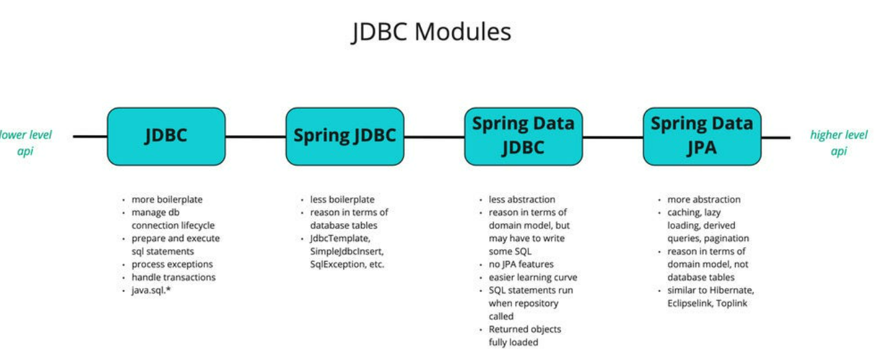

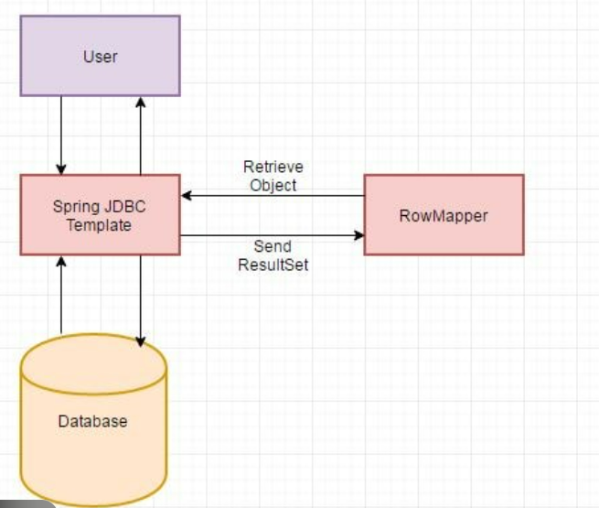

WHEN to Use NamedParameterJdbcTemplate
✅ INSERT / UPDATE with many fields
✅ Dynamic SQL
✅ Readability required
✅ Real-world enterprise apps

✅ Project Name: SpringJdbcNamedParamDemo

What you will build
- Oracle table: employee
- REST APIs:
  - GET /employees → list all employees
  - POST /employee → insert employee (named parameters)
  - GET /employee/{id} → get employee by id (named parameters)

✅ Prerequisites (Before Start)

✅ You must have:
- Oracle XE running (XE / 21c etc.)
- Java 17+ installed (recommended)
- STS / Eclipse / IntelliJ
- Maven (comes with Spring Boot projects)

STEP 1 — Create Oracle Table + Data
Open SQL Plus / SQL Developer and run:
CREATE TABLE employee (
id NUMBER PRIMARY KEY,
name VARCHAR2(50),
salary NUMBER
);

INSERT INTO employee VALUES (1, 'Ravi', 50000);
INSERT INTO employee VALUES (2, 'Anu', 60000);
INSERT INTO employee VALUES (3, 'Kiran', 55000);

COMMIT;

SELECT * FROM employee;
✅ Confirm that table and data exist.

STEP 2 — Create New Spring Boot Project in STS

In STS:
- File → New → Spring Starter Project
- Project name: SpringJdbcNamedParamDemo
- Group: com.example
- Artifact: SpringJdbcNamedParamDemo
- Packaging: Jar
- Java: 17
- Dependencies select:
✅ Spring Web
✅ Spring JDBC
Click Finish.

STEP 3 — Add Oracle JDBC Driver

Option A (Maven dependency) ✅
Open pom.xml and add:
<dependency>
<groupId>com.oracle.database.jdbc</groupId>
<artifactId>ojdbc8</artifactId>
<version>19.3.0.0</version>
</dependency>

After adding:
✅ Right click project → Maven → Update Project
If this dependency doesn’t download due to Oracle restrictions, use Option B.

Option B (Manual Jar) ✅ (Most reliable)
- Download ojdbc8.jar
- In STS:
  - Right click project → Build Path → Configure Build Path
  - Libraries → Add External JARs
  - Select ojdbc8.jar
  - Apply & Close

STEP 4 — Configure Database in application.properties
Go to:
src/main/resources/application.properties
Add:
spring.application.name=SpringJdbcNamedParamDemo

spring.datasource.url=jdbc:oracle:thin:@localhost:1521:XE
spring.datasource.username=system
spring.datasource.password=admin
spring.datasource.driver-class-name=oracle.jdbc.OracleDriver

server.port=9999
✅ Use correct username/password according to your DB.

STEP 5 — Create Employee Model (POJO)
Create file:
src/main/java/com/example/demo/Employee.java
package com.example.demo;

public class Employee {

private int id;
private String name;
private int salary;

public Employee() {}

public Employee(int id, String name, int salary) {
this.id = id;
this.name = name;
this.salary = salary;
}

public int getId() { return id; }
public void setId(int id) { this.id = id; }

public String getName() { return name; }
public void setName(String name) { this.name = name; }

public int getSalary() { return salary; }
public void setSalary(int salary) { this.salary = salary; }
}

STEP 6 — Create RowMapper
Create file:
EmployeeRowMapper.java
package com.example.demo;

import java.sql.ResultSet;
import java.sql.SQLException;

import org.springframework.jdbc.core.RowMapper;

public class EmployeeRowMapper implements RowMapper<Employee> {

@Override
public Employee mapRow(ResultSet rs, int rowNum) throws SQLException {

Employee emp = new Employee();
emp.setId(rs.getInt("id"));
emp.setName(rs.getString("name"));
emp.setSalary(rs.getInt("salary"));

return emp;
}
}

STEP 7 — Create DAO using NamedParameterJdbcTemplate ✅
Create file:
EmployeeDao.java
package com.example.demo;

import java.util.List;
import java.util.Map;

import org.springframework.jdbc.core.namedparam.BeanPropertySqlParameterSource;
import org.springframework.jdbc.core.namedparam.NamedParameterJdbcTemplate;
import org.springframework.stereotype.Repository;

@Repository
public class EmployeeDao {

private final NamedParameterJdbcTemplate namedJdbcTemplate;

public EmployeeDao(NamedParameterJdbcTemplate namedJdbcTemplate) {
this.namedJdbcTemplate = namedJdbcTemplate;
}

// ✅ GET ALL
public List<Employee> getAllEmployees() {
String sql = "SELECT * FROM employee";
return namedJdbcTemplate.query(sql, Map.of(), new EmployeeRowMapper());
}

// ✅ GET BY ID (Named Parameter)
public Employee getEmployeeById(int id) {
String sql = "SELECT * FROM employee WHERE id = :id";
return namedJdbcTemplate.queryForObject(sql, Map.of("id", id), new EmployeeRowMapper());
}

// ✅ INSERT (Named Parameters)
public int addEmployee(Employee emp) {
String sql = """
INSERT INTO employee (id, name, salary)
VALUES (:id, :name, :salary)
""";

return namedJdbcTemplate.update(sql, new BeanPropertySqlParameterSource(emp));
}
}

STEP 8 — Create REST Controller
Create file:
EmployeeController.java
package com.example.demo;

import java.util.List;

import org.springframework.web.bind.annotation.*;

@RestController
public class EmployeeController {

private final EmployeeDao employeeDao;

public EmployeeController(EmployeeDao employeeDao) {
this.employeeDao = employeeDao;
}

// ✅ GET ALL
@GetMapping("/employees")
public List<Employee> getEmployees() {
return employeeDao.getAllEmployees();
}

// ✅ GET BY ID
@GetMapping("/employee/{id}")
public Employee getEmployee(@PathVariable int id) {
return employeeDao.getEmployeeById(id);
}

// ✅ INSERT
@PostMapping("/employee")
public String addEmployee(@RequestBody Employee emp) {
employeeDao.addEmployee(emp);
return "Employee Added Successfully";
}
}

STEP 9 — Main Class (Already Created by Spring)
Open:
SpringJdbcNamedParamDemoApplication.java
Ensure it looks like:
package com.example.demo;

import org.springframework.boot.SpringApplication;
import org.springframework.boot.autoconfigure.SpringBootApplication;

@SpringBootApplication
public class SpringJdbcNamedParamDemoApplication {

public static void main(String[] args) {
SpringApplication.run(SpringJdbcNamedParamDemoApplication.class, args);
}
}

STEP 10 — Run the Application ✅
In STS:
- Right click main class → Run As → Spring Boot App
Expected startup log:
✅ Hikari pool starts
✅ Tomcat runs on 9999

STEP 11 — Test APIs (Browser + Postman)

✅ Test 1: Get All
Browser:
http://localhost:9999/employees

✅ Test 2: Get By ID
Browser:
http://localhost:9999/employee/1

✅ Test 3: Insert Employee (Postman)
POST:
http://localhost:9999/employee
Body JSON:
{
"id": 10,
"name": "Suresh",
"salary": 65000
}
Then check:
http://localhost:9999/employees

